# Appendix B

# Uni- and Bivariate Sample Descriptives

The total sample consisted of 55,593 participants. Mean age was 33.06 (SD = 11.68). With respect to gender, 67% of participants reported female, 32% reported male, 1% reported “other.” With respect to marital status, 58% of participants reported being never married, 33% reported being currently married, 8% reported being previously married. With respect to type of area lived in when a child, 22% of participants reported rural, 37% reported suburban, 40% reported urban. With respect to language, 66% of participants reported that English is their native language, 34% reported that English is not their native language. With respect to race, 20% reported Asian, 1% reported Arab, 7% reported Black, 61% reported White, Native American, or Indigenous Australian (note that these three options were merged due to a coding mistake), and 1% did not report race.

**Figure B1**  
*Univariate distributions of the RIASEC subscale scores ()* 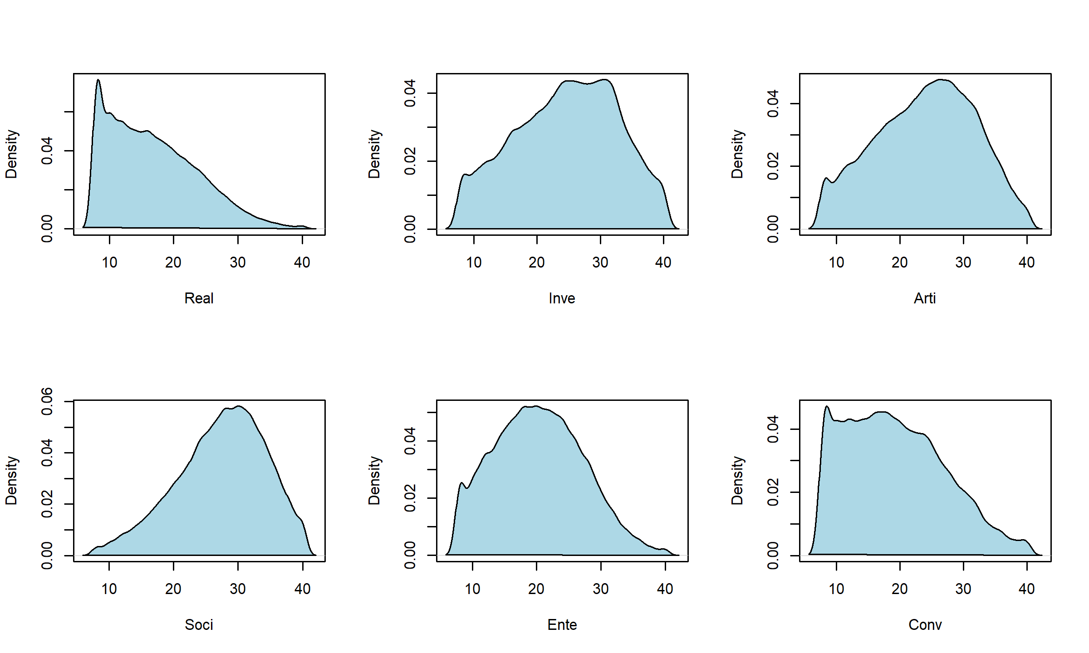

**Table B1**  
*Pearson correlations between RIASEC subscale scores ()*

|  |  |  |  |  |  |  |
| --- | --- | --- | --- | --- | --- | --- |
|  | **Real** | **Inve** | **Arti** | **Soci** | **Ente** | **Conv** |
| **Real** | 1.000 | 0.332 | 0.182 | 0.049 | 0.305 | 0.460 |
| **Inve** | 0.332 | 1.000 | 0.329 | 0.141 | 0.016 | 0.065 |
| **Arti** | 0.182 | 0.329 | 1.000 | 0.290 | 0.253 | -0.056 |
| **Soci** | 0.049 | 0.141 | 0.290 | 1.000 | 0.356 | 0.124 |
| **Ente** | 0.305 | 0.016 | 0.253 | 0.356 | 1.000 | 0.464 |
| **Conv** | 0.460 | 0.065 | -0.056 | 0.124 | 0.464 | 1.000 |